Project Design Phase
Problem – Solution Fit Template
Date | 20 FEB 2026
Team ID | LTVIP2026TMIDS78860
Project Name | Calculating Family Expenses using Service Now
Maximum Marks | 2 Marks

Problem – Solution Fit Template:
The “Calculating Family Expenses using ServiceNow” project aims to address the common challenges faced by families and individuals in managing their personal finances effectively. Many people struggle to record and analyze their daily and monthly expenses, often relying on manual or inconsistent methods like notebooks
or spreadsheets. This leads to inaccurate tracking, lack of insights, and overspending without awareness.
To overcome these challenges, the proposed solution leverages ServiceNow to automate and streamline expense management. By using ServiceNow’s workflow automation, data management, and reporting capabilities, users can easily record, categorize, and monitor their expenses in real time. The system provides budget alerts, visual dashboards, and spending summaries to help users stay within their financial limits and plan more effectively.
This alignment between the problem (manual, error-prone expense tracking) and the solution (automated, intelligent expense management through ServiceNow) ensures a clear fit, offering users convenience, accuracy, and actionable financial insights.
Purpose:
- To simplify and automate the process of recording and tracking family and individual expenses.
- To reduce errors and time spent on manual expense calculations.
- To categorize expenses (e.g., food, rent, utilities, entertainment) for better financial understanding.
- To provide real-time insights, reports, and visual dashboards for smarter decision-making.
- To set up automated budget alerts and notifications to prevent overspending.
- To ensure secure and centralized storage of financial data within ServiceNow.
- To promote better financial planning and awareness among users.
- To utilize ServiceNow’s workflow automation and reporting features for efficient expense management.
Template:
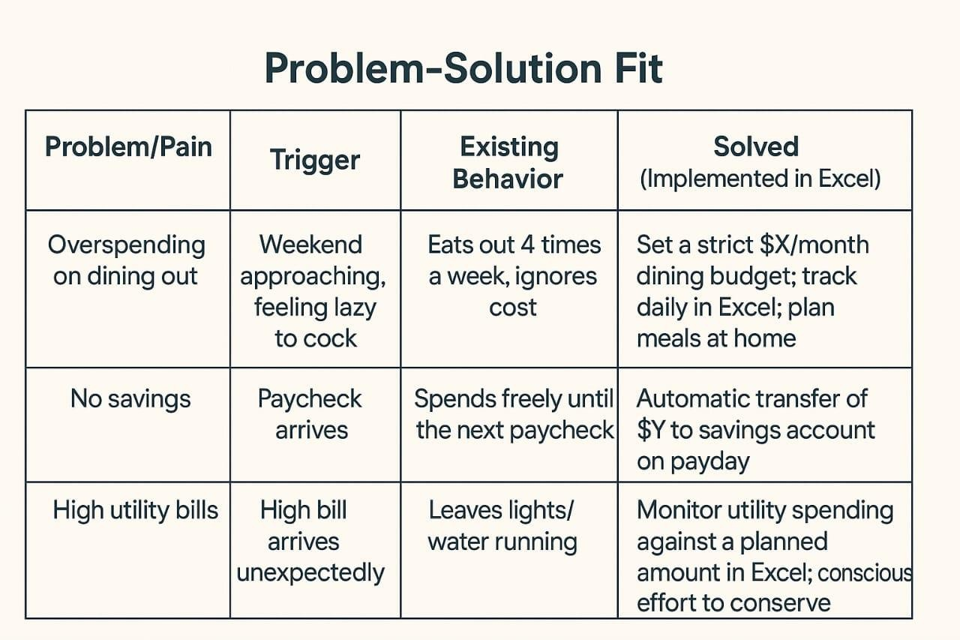
The Calculating Family Expenses using ServiceNow project successfully demonstrates how a digital workflow platform can simplify and automate household financial management. By identifying key pain points such as lack of expense visibility, difficulty in tracking spending habits, and manual recordkeeping errors, the project provides a structured and user-friendly solution through the ServiceNow environment.
The proposed solution enables families to record, categorize, and analyze their daily, weekly, and monthly expenses with real-time dashboards and reports. It helps users set spending limits, monitor savings goals, and make informed financial decisions. ServiceNow’s automation and cloud-based architecture ensure that data is securely stored, easily accessible, and seamlessly updated without manual effort.
Overall, the Problem–Solution Fit confirms that using ServiceNow as a platform for family expense management effectively bridges the gap between traditional manual budgeting and modern digital finance tracking. It promotes better financial awareness, accountability, and planning within households, ultimately leading to improved savings and smarter spending habits.

